REPRIEVE Social Media Messages
General Messages | Tweet | Facebook | Brief (newsletter, email) | Image
For release by the study/sponsor/collaborators/partners.  Participating sites can share/like the messages or revise and post on their own pending local IRB approval. | #NIH seeks to prevent #CVD in people with #HIV! Volunteers needed for the @reprievetrial bit.ly/1RRqL7y | People with #HIV are living longer thanks to ART, but are also at increased risk for other serious health conditions. NIH's @REPRIEVEtrial seeks volunteers ages 40-75 to help test a strategy to prevent heart disease in people living with HIV. Learn more: www.reprievetrial.org | Over Age 39? You May Qualify for the REPRIEVE Trial  Heart disease among HIV-infected individuals is emerging as a major public health problem despite effective treatments that suppress viral load. People living with HIV are 50 to 100% more likely to develop heart disease, including heart attack and stroke, compared with people who do not have HIV. Currently, there are no approved strategies for heart disease prevention tailored to people living with HIV. But REPRIEVE, which stands for a Randomized Trial to Prevent Vascular Events in HIV, is a large-scale randomized clinical research trial looking to change that fact.  The trial—supported by the National Institutes of Health—will test whether a daily dose of a statin (pitavastatin) reduces the risk of heart disease among HIV-infected individuals. You may qualify to participate in REPRIEVE if you:  • Are HIV positive  • Are between the ages of 40 and 75  • Have been on antiretroviral therapy (ART) for at least 6 months prior to study entry  • Have no history of heart disease (including heart attack or stroke)  • Are not currently using a statin drug  Please consider taking part in this historic chance to address the growing problem of HIV-related heart disease. Visit www.reprievetrial.org or call 1-877-29-HEART today. | 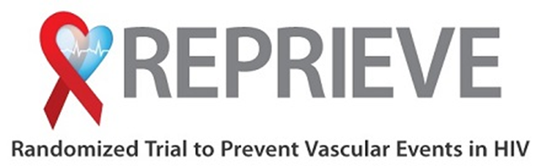
 | People with #HIV ages 40-75 taking ART may be eligible for the @reprievetrial bit.ly/1RRqL7y | Participating in the #NIH @reprievetrial is not about "adding another pill" to ART, it's about paving the way to healthier hearts for the #HIV community. Learn more: www.reprievetrial.org |  | 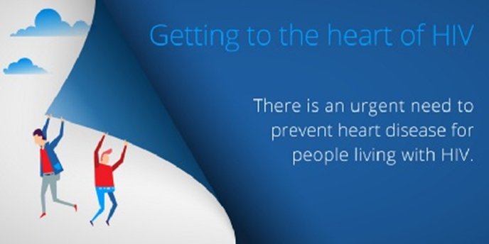
 | People w/#HIV are up to 2x as likely to develop #HeartDisease. See how #NIH is addressing this problem bit.ly/1RkNQd8 | Did you know women & men living with #HIV are up to twice as likely to develop #HeartDisease? See how @nih.gov's REPRIEVE clinical trial is addressing this problem. Learn more: www.reprievetrial.org http://www.youtube.com/watch?v=MNDKfsAkNDQ |  | embed YouTube video: http://www.youtube.com/watch?v=MNDKfsAkNDQ
Women-Specific Messages | Tweet | Facebook | Brief (newsletter, website) | Image
For release by the study/sponsor/collaborators/partners.  Participating sites can share/like the messages or revise and post on their own pending local IRB approval. | Join #FollowYourHeart! @reprievetrial investigates sex differences in preventing #HeartDisease in adults living w/ #HIV. bit.ly/1qmui1q | Join the women's initiative of NIH's @reprievetrial to help assess sex-specific differences of cardiovascular disease risk in people with #HIV. Learn more: http://followyourheart.reprievetrial.org/ #FollowYourHeart |  | 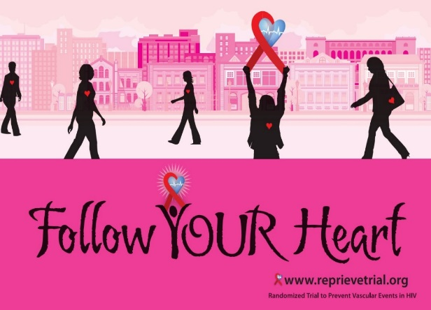
 | Women’s hearts may respond differently to #HIV. @reprievetrial is launching a campaign to find out more: bit.ly/1qmui1q #FollowYourHeart | Women with HIV are up to 3 times more likely to have a heart attack than women without HIV. That’s why the REPRIEVE trial from #NIH has launched #FollowYourHeart, a campaign encouraging HIV-positive women to learn more about their risk of cardiovascular disease and consider enrolling in REPRIEVE. Learn more: http://followyourheart.reprievetrial.org/
Awareness Period Messages | Tweet | Facebook | Brief (newsletter, website) | Image
American Heart Month, February
For release by the study/sponsor/collaborators/partners.  Participating sites can share/like the messages or revise and post on their own pending local IRB approval. | DYK people with #HIV are up to 2x more likely to have a heart attack? Learn more at reprievetrial.org #HeartHealth | February is National Heart Month! Did you know that people living with #HIV are 50-100% more likely to have a heart attack or another form of cardiovascular disease? Learn more about this HIV-CVD connection and a trial you may be eligible to participate in at www.reprievetrial.org. #HeartHealth
 | #HIV raises your risk of heart disease--but researchers are testing if statins can help. Consider volunteering for @reprievetrial #HeartHealth | February is National Heart Month! If you are #HIV positive, you may be at an increased risk of developing heart disease. But researchers are currently asking if statins may be able to help lower this risk. Consider volunteering for the REPRIEVE trial at www.reprievetrial.org. #HeartHealth
 | Feb is Heart Month! #NIH seeks to address #HeartHealth in people with #HIV! Volunteers needed for the @reprievetrial | February is National Heart Month! #NIH is currently seeking strategies to address the increased risk of heart disease in people living with #HIV, and volunteers are urgently needed! Learn more at www.reprievetrial.org. #HeartHealth |  | 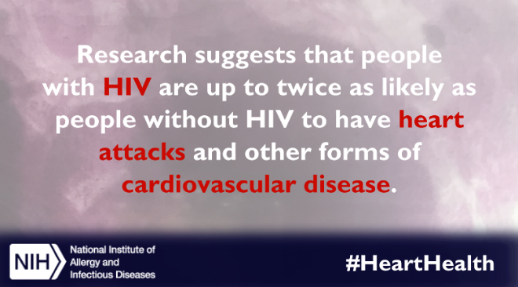
National Black HIV/AIDS Awareness Day, February 7
For release by the study/sponsor/collaborators/partners.  Participating sites can share/like the messages or revise and post on their own pending local IRB approval. | Today is #NBHAAD: DYK #HIV increases the risk of #heartdisease? See how #NIH is addressing this problem bit.ly/1RRqL7y | Today is National Black HIV/AIDS Awareness Day. Heart disease is a health issue that disproportionately affects African Americans. But did you know that #HIV can increase the risk of developing heart disease as well? See how #NIH is addressing this problem with the REPRIEVE clinical trial. #NBHAAD |  | embed video: http://www.youtube.com/watch?v=MNDKfsAkNDQ
National Women and Girls HIV/AIDS Awareness Day, March 10
For release by the study/sponsor/collaborators/partners.  Participating sites can share/like the messages or revise and post on their own pending local IRB approval. | Today is #NWGHAAD: DYK #HIV increases the risk of #heartdisease? See how #NIH is addressing this problem bit.ly/1RRqL7y | Today is National Women & Girls HIV/AIDS Awareness Day. Heart disease is the leading cause of death in American women. But did you know that #HIV can further increase your risk? See how #NIH is addressing this problem with the REPRIEVE clinical trial. #NWGHAAD
National HIV/AIDS and Aging Awareness Day, September 18
For release by the study/sponsor/collaborators/partners.  Participating sites can share/like the messages or revise and post on their own pending local IRB approval. | Aging with #HIV? Learn more about how you might be at risk of #heartdisease: reprievetrial.org #NHAAAD | Today is National HIV/AIDS and Aging Awareness Day. Thanks to improved therapies, people with #HIV are living longer, healthier lives. But while cardiovascular disease is a concern for many older people, having #HIV may put you at a higher risk of experiencing a heart attack or stroke. Learn more about the CVD-HIV connection and consider enrolling in a clinical trial at www.reprievetrial.org. #NHAAAD
 | It’s #NHAAAD. @reprievetrial is looking for HIV+ volunteers 40-75 to learn more about #HIV and #heartdisease | Today is National HIV/AIDS and Aging Awareness Day. The REPRIEVE trial from #NIH is looking for #HIV positive volunteers ages 40-75 to learn more about the connection between HIV and heart disease. You may be eligible to participate! Learn more at www.reprievetrial.org. #NHAAAD http://www.youtube.com/watch?v=MNDKfsAkNDQ |  | embed video: http://www.youtube.com/watch?v=MNDKfsAkNDQ
National Latino AIDS Awareness Day, October 15
For release by the study/sponsor/collaborators/partners.  Participating sites can share/like the messages or revise and post on their own pending local IRB approval. | Today is #NLAAD: DYK #HIV increases the risk of #heartdisease? See how #NIH is addressing this problem http://bit.ly/1RkNQd8 | Today is National Latino AIDS Awareness Day. Did you know that living with #HIV can increase your risk of developing heart disease? See how #NIH is addressing this problem with the REPRIEVE clinical trial. #NLAAD
ID Week, October 4-8, 2017 (October, changes annually)
For release by the study/sponsor/collaborators/partners.  Participating sites can share/like the messages or revise and post on their own pending local IRB approval. | It's #IDweek2016! DYK #HIV increases the risk of #heartdisease? See how #NIH is addressing this problem http://bit.ly/1RkNQd8 | It's Infectious Disease Week 2016! Much progress has been made in understanding the connections between infectious diseases, like #HIV, and other chronic conditions. For example, did you know living with HIV increases your risk of developing heart disease? See how #NIH is trying to get in front of this problem and learn more with the REPRIEVE clinical trial. Learn more at www.reprievetrial.org. #IDweek2016 http://www.youtube.com/watch?v=MNDKfsAkNDQ |  | embed video: http://www.youtube.com/watch?v=MNDKfsAkNDQ
World AIDS Day, December 1
For release by the study/sponsor/collaborators/partners.  Participating sites can share/like the messages or revise and post on their own pending local IRB approval. | DYK as #AIDS deaths decrease in the US, #heartdisease deaths among those w/#HIV increase? Learn more: http://bit.ly/1RkNQd8 #WorldAIDSDay | Today, we observe #WorldAIDSDay. Did you know that even though deaths from #AIDS-related morbidities are decreasing in the United States, heart disease deaths among those living with #HIV are increasing? People living with HIV are 50-100% more likely than the general population to develop cardiovascular disease. Learn more about the CVD-HIV connection at www.reprievetrial.org and see how #NIH is addressing this serious problem: http://www.youtube.com/watch?v=MNDKfsAkNDQ |  | Embed video: http://www.youtube.com/watch?v=MNDKfsAkNDQ
 | #WorldAIDSDay reminds us how important it is to participate in research. People with #HIV ages 40-75 may be eligible for the @reprievetrial | #WorldAIDSDay reminds us how critical clinical trial research has been to advancing medical science on HIV/AIDS, but more research is still needed! If you are #HIV positive and between the ages of 40 and 75, you may be eligible to participate in a trial studying the connection between HIV and heart disease. Learn more at www.reprievetrial.org.

